Thesis Report: Fake News Detection Using Machine Learning and Transformer Models

CHAPTER 1: INTRODUCTION
1.1 Background
The exponential growth of online media platforms has fundamentally transformed the global information landscape, facilitating the rapid exchange of data across the internet. While this evolution has democratized access to information, it has concurrently enabled the widespread dissemination of misinformation and "fake news". Broadly defined, fake news involves the intentional distribution of misleading or false information presented under the guise of legitimate journalism. The proliferation of such content can skew public opinion, undermine political integrity, and incite social instability. Given the public's increasing reliance on digital media for news consumption, developing robust, automated detection systems has become a critical necessity. To this end, machine learning and natural language processing (NLP) have emerged as essential methodologies for identifying deceptive content by analyzing intricate textual patterns and linguistic features.
1.2 Problem Statement
Conventional manual fact-checking is inherently labor-intensive and fails to scale effectively against the massive volume of digital information generated daily. Consequently, there is an urgent need for automated systems capable of efficiently identifying misleading content. However, classical machine learning models frequently struggle to interpret the nuanced contextual relationships inherent in human language. This limitation underscores the necessity of exploring advanced deep learning architectures—specifically transformer-based models—to enhance the accuracy of fake news detection.
1.3 Research Objectives
The primary objectives of this research are as follows:
- To design and implement a fake news detection system utilizing machine learning methodologies.
- To conduct a comparative analysis of the performance of classical machine learning models against transformer-based architectures.
- To assess the specific efficacy of transformer models in the context of misinformation detection.
1.4 Research Questions
This study addresses the following key questions:
- How effective are classical machine learning models at detecting fake news?
- Do transformer-based models demonstrably outperform traditional machine learning approaches?
- What specific architectural advantages do transformer models offer for fake news detection?
1.5 Significance of the Study
This research contributes to the development of intelligent systems designed to automate the identification of misinformation. The findings offer practical utility for social media platforms, news organizations, and fact-checking agencies in their efforts to mitigate the spread of fake news.

CHAPTER 2: LITERATURE REVIEW
Scholarship in this field has historically explored various machine learning and deep learning strategies for fake news detection. Initial research efforts centered on traditional techniques such as Naive Bayes, Support Vector Machines (SVM), and Logistic Regression. These methodologies typically rely on feature extraction techniques, including:
- Bag-of-Words
- TF-IDF (Term Frequency-Inverse Document Frequency)
- N-gram analysis
While effective for basic classification, these classical approaches often fail to capture the deep contextual meaning within a text. More recently, deep learning frameworks—such as Recurrent Neural Networks (RNN) and Long Short-Term Memory (LSTM) networks—have been introduced to address these gaps. Transformer architectures, specifically BERT and GPT-based models, have established new benchmarks in NLP due to their ability to model complex bidirectional contextual relationships between words. This study builds upon these advancements by evaluating the comparative performance of traditional models and modern transformer-based architectures.

CHAPTER 3: METHODOLOGY
3.1 Dataset and Preprocessing
The dataset employed in this research consists of labeled news articles categorized as either "real" or "fake". To evaluate model performance, the data was partitioned into training and testing sets, with the test set comprising 1,800 samples. Textual data underwent a rigorous preprocessing pipeline to reduce noise and optimize performance:
- Normalization: Lowercasing and text normalization.
- Cleaning: Removing punctuation and eliminating stopwords.
- Tokenization: Segmenting text into individual tokens.
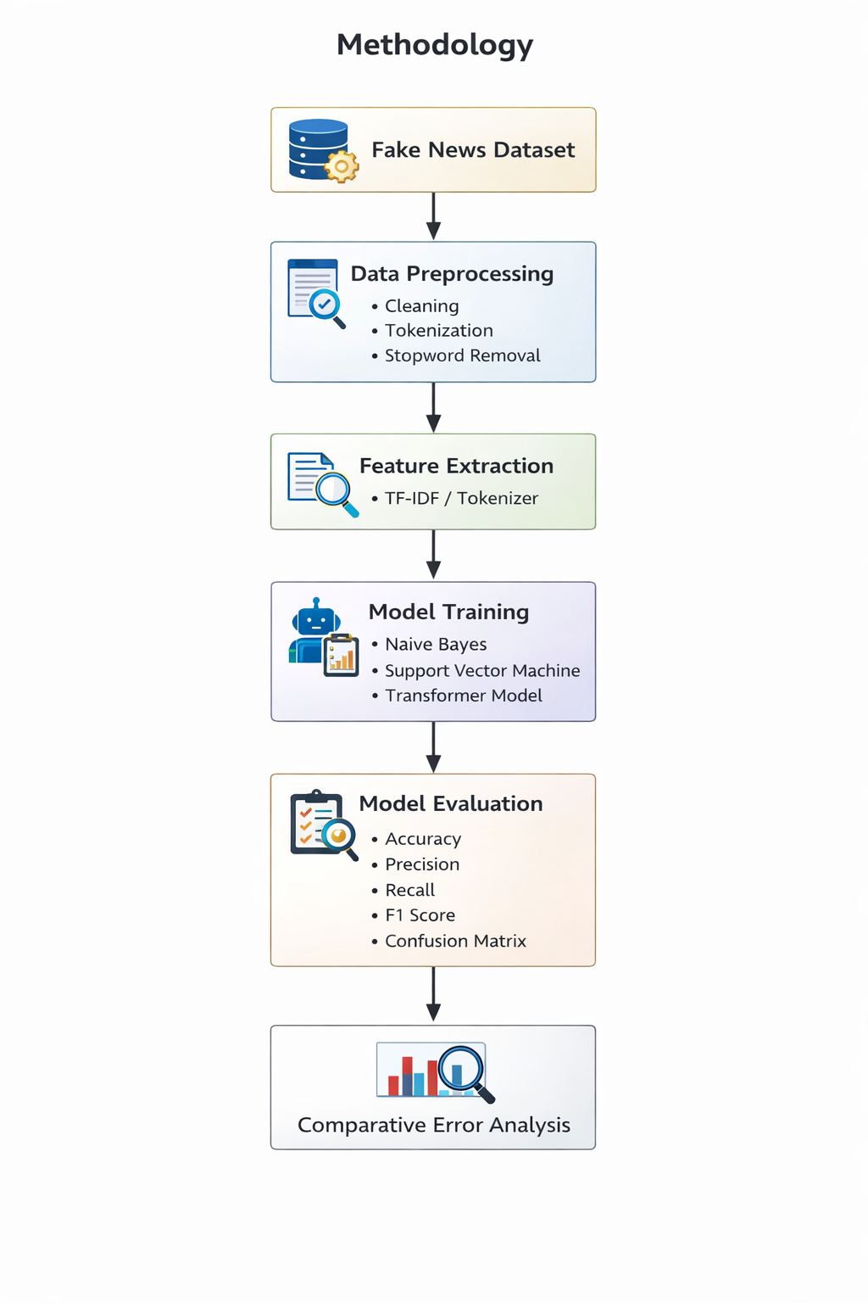
3.2 Models and Evaluation
Three distinct models were implemented for comparison:
- Naive Bayes: A probabilistic classifier based on Bayes' theorem, assuming feature independence.
- Support Vector Machine (SVM): A supervised algorithm that identifies the optimal hyperplane to separate classes in a high-dimensional feature space.
- Transformer Model: An architecture utilizing self-attention mechanisms to capture nuanced contextual relationships.
The models were assessed using standard classification metrics: Accuracy, Precision, Recall, F1-score, and a Confusion M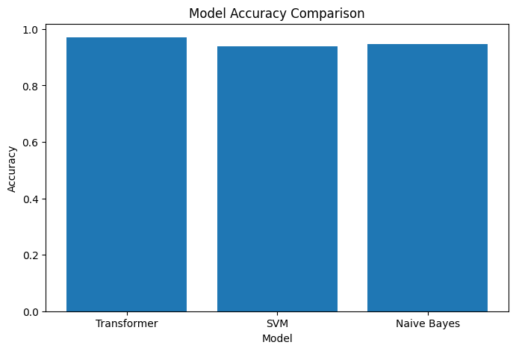atrix.
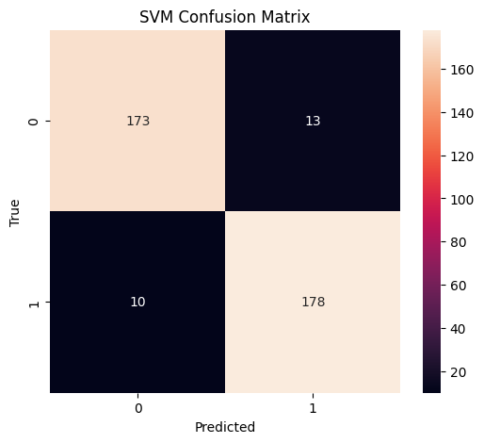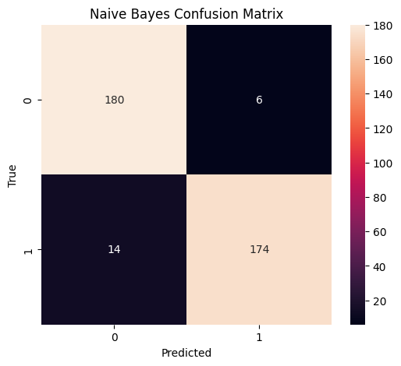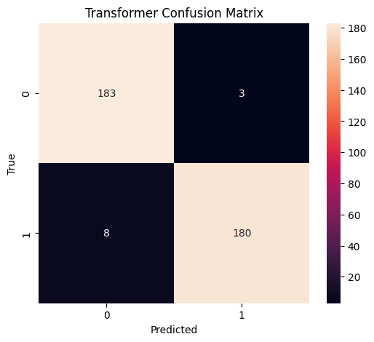

CHAPTER 4: SYSTEM DESIGN
The proposed detection system follows a structured pipeline. The workflow begins when a user inputs a news article, which then undergoes text preprocessing. The refined text is processed by the trained model, which generates a final prediction regarding the article's authenticity.
4.1 Prototype and Implementation
A prototype was developed using Streamlit to demonstrate the practical application of the transformer model. Users can interact with a web-based interface to input text and receive real-time predictions. The backend implementation was built using Python, leveraging Pandas for data processing, Scikit-Learn for traditional ML, and the Transformers library for deep learning.
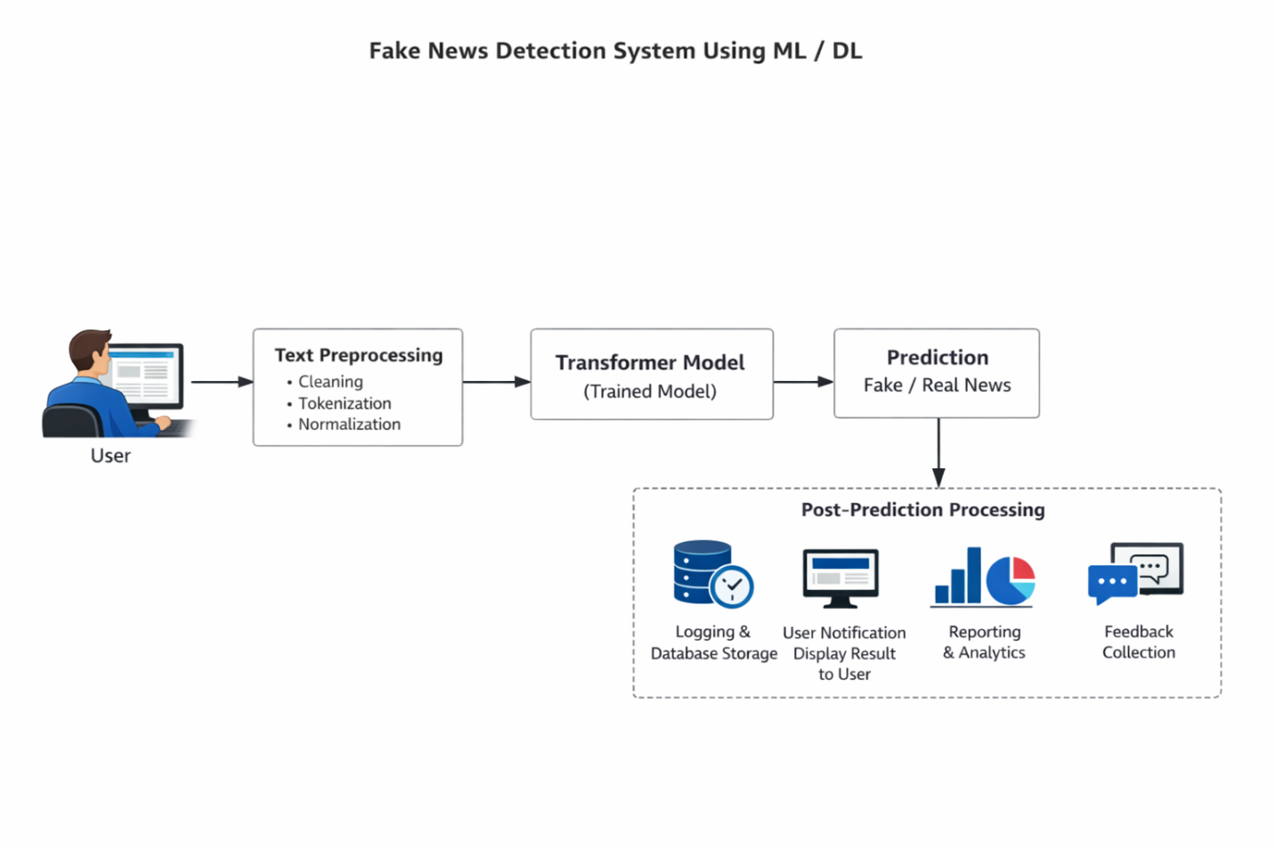

Component | Technology
Programming Language | Python
Data Processing | Pandas
Machine Learning | Scikit-Learn
Deep Learning | Transformers
Visualization | Matplotlib / Seaborn
Prototype Interface | Streamlit

CHAPTER 5: RESULTS AND DISCUSSION
5.1 Performance Evaluation
Experimental results on the 1,800-article test set demonstrate that the transformer-based model achieved the highest overall performance.
Model | Accuracy | Total Errors
Transformer | 97.06% | 11
Naive Bayes | 94.65% | 20
SVM | 93.85% | 23
5.2 Comparative Analysis
The Transformer model exhibited superior generalization capabilities, particularly in its contextual understanding of semantic relationships. It achieved a balanced F1-score of 0.97 for both real and fake news categories. While Naive Bayes and SVM performed admirably (94.65% and 93.85% respectively), they produced significantly more classification errors. The high recall for fake news (0.96) in the transformer model is particularly significant, as it ensures that fewer deceptive articles are misclassified as legitimate.

CHAPTER 6: CONCLUSION
This study confirms that transformer-based architectures provide a substantial improvement over classical machine learning for fake news detection. With a peak accuracy of 97.06%, the transformer model effectively addresses the challenges of contextual ambiguity in textual data. Future research should investigate the application of these models to larger datasets and explore even more advanced architectures to further enhance detection precision.

REFERENCES
Devlin, J., Chang, M. W., Lee, K., & Toutanova, K. (2019). BERT: Pre-training of deep bidirectional transformers for language understanding. Proceedings of the 2019 Conference of the North American Chapter of the Association for Computational Linguistics.
Vaswani, A., Shazeer, N., Parmar, N., Uszkoreit, J., Jones, L., Gomez, A. N., Kaiser, Ł., & Polosukhin, I. (2017). Attention is all you need. Advances in Neural Information Processing Systems.
Shu, K., Sliva, A., Wang, S., Tang, J., & Liu, H. (2017). Fake news detection on social media: A data mining perspective. ACM SIGKDD Explorations.
Zhang, X., Zhao, J., & LeCun, Y. (2015). Character-level convolutional networks for text classification. Advances in Neural Information Processing Systems.
Pedregosa, F., Varoquaux, G., Gramfort, A., Michel, V., Thirion, B., Grisel, O., Blondel, M., Prettenhofer, P., Weiss, R., Dubourg, V., Vanderplas, J., Passos, A., Cournapeau, D., Brucher, M., Perrot, M., & Duchesnay, É. (2011). Scikit-learn: Machine learning in Python. Journal of Machine Learning Research.

